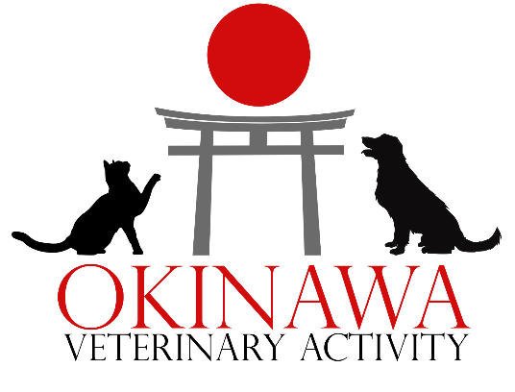
PCS CHECKLIST FOR PETS TO THE CONTINENTAL USA

- Vaccinations – Ensure your pet(s) rabies vaccinations are current, administered at least 30 days prior to departure. It is also recommended to update your pet(s) core vaccines. You will need to obtain a bilingual or English only original rabies certificate.
- Medical history – You will need to obtain an updated vaccination record. If your pet has received care at a civilian veterinary clinic, it is recommended to obtain a copy of your pets’ complete medical record.
- MDJ 270 – If your pet was brought to Japan, you will need to obtain a copy of their signed MDJ 270. This form is not necessary for pets that were born in and have never left Japan.
- CDC Dog Import Form (DOGS ONLY) – You will need to complete the CDC Dog Import Form prior arriving in the United States. This form is done online and can be completed up to six months in advance. The form can be found here: https://www.cdc.gov/importation/dogs/dog-import-form-instructions.html
- Health Certificate Appointment – You will need to schedule a Health Certificate Exam for your pet(s) within a few days of their departure to assess whether the pet appears healthy enough to travel and verify the pet is showing no symptoms of communicable disease. This exam can be done at Okinawa VETAC or at a civilian veterinary clinic. After your pet is examined by a veterinarian, you will receive the following documents:
  - Health Certificate – Valid for 10 calendar days of travel, starting the date of the appointment. If your travel will exceed 10 days, you will need more than one Health Certificate Exam.
  - Letter of Acclimation – states that your pet is approved to fly by a veterinarian under certain conditions. It does not guarantee that your pet will be allowed to fly, as this will depend on the airline.
- If your pet will be flying commercial – You will need to schedule an export inspection appointment with Naha Animal Quarantine Service in addition to the Health Certificate Exam. This appointment can be scheduled by contacting Animal Quarantine Service at aqs.nap@maff.go.jp
- If your pet will be flying AMC – Contact the AMC terminal for the most up-to-date procedures for pet export.
- After the Health Certificate Appointment, make copies of the following documents:
    - Health Certificate x5
    - Letter of Acclimation x5
    - Rabies Certificate x5
    - Orders x2
    - MDJ 270 x2 (if applicable)
- Day before/Day of flight:
  - Stop feeding 6-8 hours before the flight.
  - Offer water before and in flight (airlines may have varying requirements for this).
  - Remove all pet accessories such as collars, leashes, and toys from the kennel and your pet.
  - Line the bottom of the kennel with something soft and absorbent, such as a towel or blanket. Do not use excessive bedding.
  - Place copies of your documents into a sealed zip lock bag and attach them to your pet(s) kennel. Retain all originals and hand carry them.

